VTOL UAV Landing Assist System

BSc Science (Honors) Computing with Software Development

Brian Clarke

Primary Supervisor: Ed Sheldon

# Table of Contents

Table of Contents 2

Table of Figures 4

Abstract 4

Research Question 5

Terminology 5

Abbreviations 5

Descriptions 5

Assumptions 6

1 Operational Goals 7

1.1 Introduction 7

1.2 Maritime UVA Mission Goals 7

1.3 Ship Interception 8

1.4 Hover over Deck 10

1.5 Landing 10

1.6 Conclusion 11

2 Operational Characteristics of the Ship 12

2.1 Waves and Sea States 12

2.2 Wind 13

2.3 The Moving Platform 14

2.4 The Operational Envelope 15

2.5 Conclusion 16

3 Operational Capabilities of the UAV 17

3.1 Overview 17

3.2 Wind 18

3.3 Performance 18

3.4 Navigation 21

3.5 Response Times 21

3.6 Camera 23

3.7 Conclusion 24

4 Final Approach 25

4.1 The Four Phases 25

4.2 Landing Approaches 25

4.3 Touchdown 25

5. Other Landing Assist Systems 27

6. System Overview 28

Libraries and Languages **Error! Bookmark not defined.**

7. Equations of Motion 32

Degrees of Freedom 34

Eularian Angles 34

The 2D Plane 34

8. Influencing Factors 34

Time Delay Factors 34

9. The UAV Model 34

10. The Ship Model 34

11. From Target Acquisition to Touchdown 34

12. Results 34

Appendix 35

Appendix 1 Douglas Sea Scale 35

Works Cited 35

# Table of Figures

Figure 1. Helicopter landing on the deck of a ship in rough seas. 7

Figure 2. Vector line diagram for the intercept path between a helicopter and a ship 8

Figure 3. Landing processes overview for the proposed system 11

Figure 4. Table of Wave types and their characteristics 12

Figure 5. Diagram Showing 6 DoF of an ocean going vessel 14

Figure 6. Table of values for 6 DoF diagram 14

Figure 7. Section of hull diagram showing changes to buoyancy 15

Figure 8. Forces acting on a helicopter in flight 18

Figure 9. Rotomotion VTOL UAV 19

Figure 10. Rotomotion’s SR200 Helicopter specification 19

Figure 11. Schiebel Camcopter S-100 VTOL UAV 20

Figure 12. Schiebel Camcopter S-100 specification 20

Figure 13. Yuan's finding for response times versus changes in vector u,v and w 22

# Abstract

This project is a mathematical model to aid in the landing of an unmanned aerial vehicle on the deck of an ocean going vessel using infra-red beacons in a predetermined pattern.

It is proposed to develop a system with output data that could be integrated with the navigational controls of a UAV as it attempts to land on the deck of a ship. The system will be required to map the space between the two bodies, both moving independently with six degrees of freedom. This mapping will then be used to determine the next course correction for the UAV, ultimately achieving a satisfactory touchdown.

The system would be aware of the ideal infra-red beacon pattern on the deck of the ship for a given altitude. Data would be streamed on a constant basis to the UAV’s navigation control system to reduce the difference between the desired pattern and the observed pattern (these patterns would be represented mathematically). These observations and corrections should result in synchronized motion between the two bodies as touchdown approaches.

# Research Question

Given a certain sea state is it possible to land a VTOL UAV autonomously on the deck of a ship using infra-red beacons in a known pattern?

# Terminology

## Abbreviations

|  |  |
| --- | --- |
| 2D | Two Dimensions |
| 3D | Three Dimensions |
| 6DoF | Six Degrees of Freedom |
| CoG | Centre of Gravity |
| GM | Metacentric Height |
| GPS | Global Position System |
| INS | Inertial Navigation Sensor |
| MRAC | Model Reference Adaptive Controller. |
| RPAS | Remotely Piloted Air System |
| UAV | Unmanned Aerial Vehicle |
| VTOL | Vertical Take Off and Landing |
| VBN | Vision Based Navigation |
|  |  |

## Descriptions

|  |  |
| --- | --- |
|  |  |
| Sea State | Douglas Sea Scale/State – This is a number devised by Captain H.P. Douglas CMG, RN in 1929 to estimate the roughness of seas and gives a range of the expected wave heights (Met Office, 2010). The full chart can be seen in Appendix ######## |
|  |  |
|  |  |
|  |  |
|  |  |

# Assumptions

It is assumed that the flight characteristics of a VTOL UAV are similar to those of its manned equivalent all other parameters being equal.

# 1 Operational Goals

## 1.1 Introduction

Unmanned aerial vehicles (UAVs) are used extensively in the military and civil sectors for a multitude of tasks including scientific endeavours, environmental data collection and military reconnaissance. Vertical Take Off and Landing (VTOL) UAV’s have an advantage over fixed wing UAV’s in that they can take off and land from any flat surface large enough, within safe operational parameters, to accommodate the vehicle. This has insured the VTOL UAV’s place in maritime operations. However landing at sea can present its own challenges if (as shown below) the poise land platform is in a constant state of change. The issue is compounded by the helicopter position and motions relative to that of the ship.

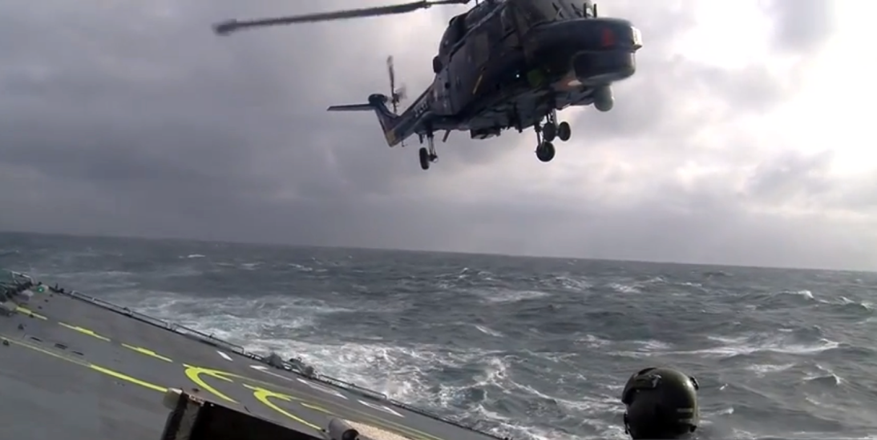

Figure 1. Helicopter landing on the deck of a ship in rough seas.

(Prism Defence, 2010)

## 1.2 Maritime UVA Mission Goals

In order to complete a safe mission a UAV must take off, achieve its primary objective, return to the ship and complete a safe touchdown. During this flow of events there are many factors that have a bearing on the success of the assignment. These include climatic wind conditions, the endurance (maximum operational time) of the UAV, the sea state the ship is operating in, the distance to the mission goal, and the relative speeds and directions of the ship and UAV. For a given set of determining factors, and operator experience, the UAV pilot will decide on the feasibility of a successful mission and act accordingly.

## 1.3 Ship Interception

In order to satisfactorily complete the mission a UAV must perform the main objective and return to the ship from which it commenced its journey. The UAV is in live contact with the UAV pilot and the ships navigational system and the distance and trajectory of an intercept path are calculated.

This optimum intercept path is calculated based on the ships current bearing and speed, data from the UAVs Inertial Navigation Sensor (INS) system, the GPS coordinates of both ship and UAV and the UAVs relative speed when present climatic conditions have been accounted for. These calculations are computed regularly and any corrective measures are implemented as soon as detected.

## 

## 

Figure 2. Vector line diagram for the intercept path between a helicopter and a ship

Where;

is the present location of the ship,

is the present location of the helicopter,

Time (T) is a moment in time when an interception is possible assuming interception is possible,

is the known velocity of the ship,

is the known velocity of the helicopter, and

is the unknown intercept angle relative to the ships trajectory.

Assuming the ship and helicopter meet at some point in time (T) then;

|  |  |  |
| --- | --- | --- |
|  |  | eq. 1 |
|  |  | eq. 2 |

Equation 2 can be extrapolated out in its x and y coordinates and squared to find two equations in T with other known variables;

|  |  |
| --- | --- |
|  | eq. 3 |
|  | eq. 4 |

If the assumption is made that the ships starting point is 0,0 and its traveling along the x axis, and knowing that;

Then if the two equations 3 and 4 are added;

|  |  |
| --- | --- |
|  | eq. 5 |

From equation 5 a value for (T) can be found that satisfies the other equations 3 or 4 and so the intercept angle relative to the ship can be calculated.

## 1.4 Hover over Deck

When the UAV has intercepted the vessel and landing is imminent, it may be necessary for the UAV to maintain a hover position a safe altitude above and slightly to the rear of the ship. At this juncture the UAV should match the ships bearing and speed and remain at its present altitude until it is time to begin final approach. At this point the UAV may have entered the operational envelope of the ship and could be prone to adverse effects on stability as it deals with the airwake of the ship and changes to the air vortices that provide lift to the aircraft.

## 1.5 Landing

“Landing a UAV is the most critical and accident prone phase of the flight” (Din, et al., 2012). There are additional factors to be considered as the UAV closes the distance between itself and the ship.

* The motion of the ship in six degrees of freedom (6DoF) as it reacts to the disruptive forces induced by the waves as they strike the ship. The two motions that have the greatest bearing on a successful landing are roll and pitch.
* The climatic winds and subsequent turbulence generated as winds traverses the deck of the ship.
* The flight dynamics of the UAV can change as it nears touchdown. The air wake below the main rotors begins to interfere with the normal operational vortex of the rotors which in turn can lead to reduced rotor efficiency. If not checked the rate of decent can increase and landing can become extremely hazardous (Padfield, 2007).
* Any masts, railing, antennas or other obstacles the may impede the helicopters approach.

All these factors must be considered to insure the landing phase and touchdown of the UAV are performed in as safe an operational envelope as possible.

The factors that influence the landing envelope and the processes involved in landing the helicopter are shown below, which also includes a proposed Model Reference Adaptive Controller. This controller bases the output to the flight controllers on the system inputs and also the previous MRAC outputs. This controller system provides a degree of “stable control during parameter uncertainty” (Kamalasadan & Ghandakly, 2011)

## 1.6 Summary

There are many factors that influence the performance of a VTOL UAV as it attempts to land on the deck of a ship. The system proposed will produce a mathematical model for the elements highlighted in the diagram of systems, shown below i.e. UAV Camera, Image Processer and Model Reference Adaptive Controller. The system will interpret the coordinates of the infra-red beacons as they might appear on a 2D plane representative of an image acquired by a camera located on the under carriage of the UAV. The then pass the transformed coordinates to the controller which will decide on the next course correction, if any, based on all the available inputs is also the last set of outputs the controller provided to the flight controls.



Figure 3. Landing processes overview for the proposed system

# 2 Operational Characteristics of the Ship

## 2.1 Waves and Sea States

As an ocean going vessel carries out its operational goals it is subjected to the forces of the sea and its local environment. The main forces acting on a vessel (excluding thrust) are those associated with waves and the ships reaction to its instability relative to the centre of gravity and buoyancy characteristics of the vessel.

In 1929 Captain H.P. Douglas CMG, RN estimated a set of codes to describe the roughness of seas and give a range of the expected wave heights (Met Office, 2010). The full chart can be seen in Appendix 1. These classifications range from Sea State 0 – 9 with respective wave heights of 0m to above 14m.

Waves can also be classified by their type and the table below shows the criteria for each type of wave.

|  |  |  |  |
| --- | --- | --- | --- |
| **Name** | **Typical Periods** | **Wave Lengths** | **Forcing Mechanism** |
| Ripples | <0.2 sec | 10-2 m | wind on sea surface |
| Sea | 0.2 – 9 sec | 130 m | wind on sea surface |
| Swell | 9 – 30 sec | 100s of metres | wind on sea surface |
| Tsunamis | 15 minutes – 1 hour | 100s of km | seismic |
| Tides | Several hours | 100s – 1000s of km | gravitational |

Figure 4. Table of Wave types and their characteristics

(Florida Centre for Instructional Technology, 2005)

Ripples are the smallest of the various types of waves and are generated as a response to light winds acting on the surface of the ocean. Sea waves are generated by stronger local winds as they act on the surface and can travel in various directions and with various speeds. Swell waves on the other hand tend to travel long distances in one direction. They are more regular in amplitude and wavelength and are normally a response to climatic conditions far away. Tsunamis and tides are other types of waves and occur as a response to global forces (Florida Centre for Instructional Technology, 2005). They also suggest that to aid in the study of waves, ideal sinusoidal shaped wave structures should be considered. A sine curve can be discribed as:

where:

= the coordinate value for y at a given time t.

= the time interval during a single sinusoidal wavelength.

= amplitude of the wave, measured from the mean value of the wave i.e. center line.

= frequency of the wave, the number of times per second the wave completes a full cycle.

For a complete study however the apparently random differences in amplitude, wavelength, and frequency within the Sea State ranges would need to be accounted for to develop a more complete model.

Individual wave types also have various characteristic based on their stage of development. During the lifecycle of a wave, it is either developing, fully developed or decaying. A wave can be said to be fully developed “when wind speed matches wave crest phase speed” (Techet A. H., 2005). A wave may travel for hundreds of miles in this state but it will start to decay if the other forces acting on the wave start to overcome the kinetic energy of the wave.

## 2.2 Wind

As described before wind plays a large part in the generation of waves which affect the vessel. To a lesser extent wind can have an effect on the performance of a ship. This effect on performance would normally not be directly attributable to the ship itself but rather the crew operating on the ship and their ability, or lack of, to perform their individual tasks. In extreme conditions however the winds impact on the ship may become more pronounced e.g. a very strong cross wind may contribute to the roll of a ship in those conditions.

One of the main concerns with wind is its interaction with the ship’s superstructure. The airwake and turbulence generated by the vessel as it passes through wind should be considered when deciding if it is appropriate to proceed with the launch or recovery of a UAV. As reported by (Snyder, 2012) wind’s “turbulent kinetic energy is significantly greater in the superstructure wake than in the free stream flow observed by the bow”. This is discussed later in this chapter during the section on the operational envelope,

## 2.3 The Moving Platform

A vessel on the surface of the ocean moves with six degrees of freedom (6DoF) and in accordance with the forces acting on it both external and internal. The two main external forces acting on a ship in the ocean are waves and gravity. There are others, such as wind and drag but both these are not as influential on the motion of the ship as waves and gravity. The internal forces acting on a ship are thrust, the reaction to instability relative to buoyancy and CoG and rudder induced turning moments. The diagram below gives a visual representation of the 6DoF for a vessel in water.

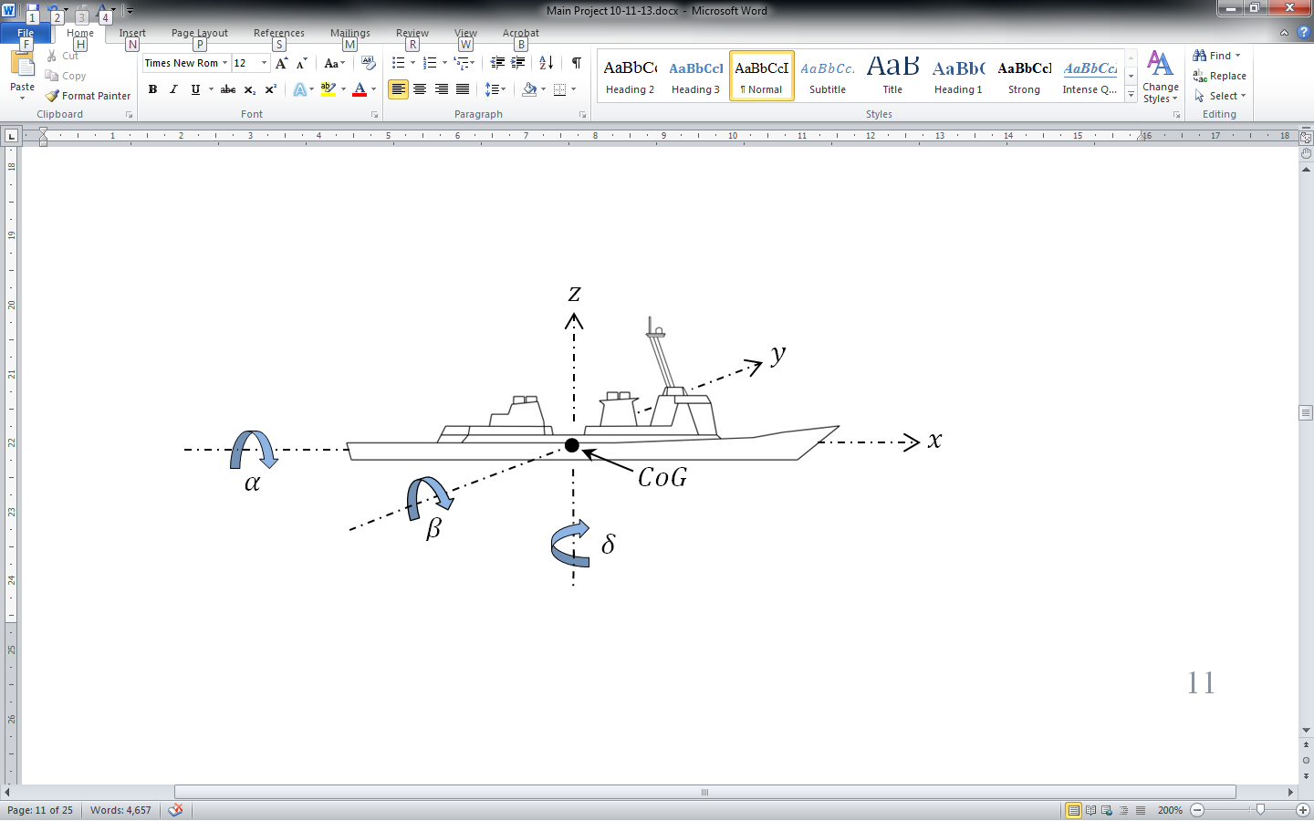

Figure 5. Diagram Showing 6 DoF of an ocean going vessel

|  |  |  |
| --- | --- | --- |
| **Name** | **Symbol** | **Description** |
| Surge |  | Thrust in the direction of |
| Sway |  | Lateral motion in the direction |
| Heave |  | Vertical motion in the direction |
| Roll |  | Rotation about the axis either |
| Pitch |  | Rotation about the axis either |
| Yaw |  | Rotation about the axis either |
| Centre of Gravity |  | One point in the ship where mass is equal in opposite directions for all 3 axis |

Figure 6. Table of values for 6 DoF diagram

## 2.4 The Operational Envelope

Modern ocean going vessel are designed to handle a variety of different sea conditions and the larger vessels in particular would be expected to be able to handle all but the very extremist of weather conditions. While the poise of a ship is in flux there are a number of forces acting and reacting on the vessel, determining the ships responses to it local environment. Some the elements involved in this interaction include:

* Buoyancy – According to Archimedes’ Principle, a vessel immersed partly or completely in a fluid receives lifting force equal to the weight of the fluid displaced by the vessel. Buoyancy acts vertically upwards.
* Gravity – The earth’s gravitational force acts in a vertically downward direction and when the vessel is completely stable cancels out the buoyancy force.
* Wave forces – The force of large waves acting on the ship can have dramatic effect to the motion of a vessel. Along with amplitude and frequency, the direction of the waves relative to the ship can have very different effects on the motion characteristics of the ship.
* Ship Characteristics – The size, centre of gravity, centre of buoyancy, metacentric height, thrust capabilities of the ship and any motion damping fins all have effect on the motion of the ship as it proceeds with its objectives.

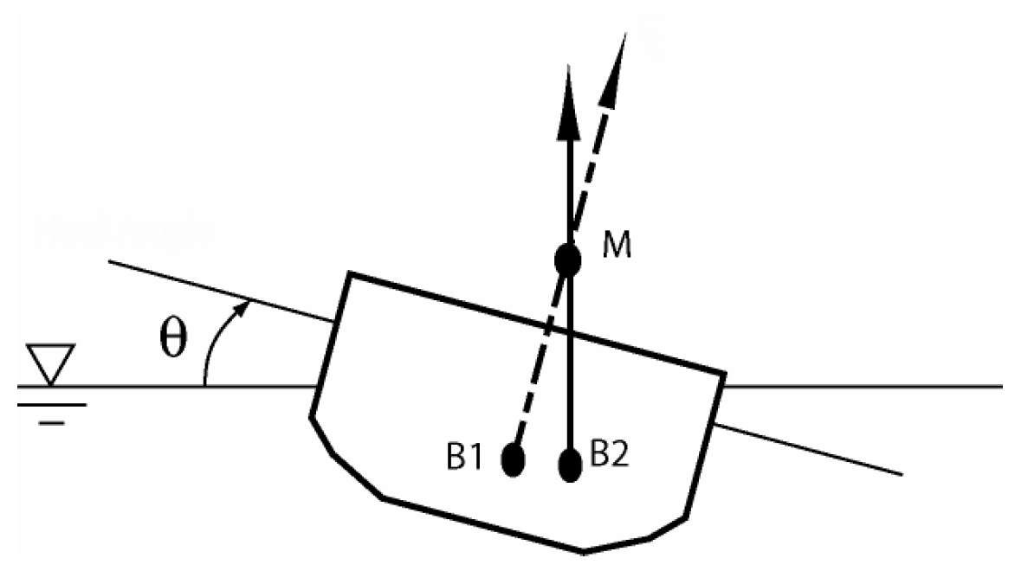

Figure 7. Section of hull diagram showing changes to buoyancy

(Techet A. H., 2004)

Where for a given roll angle of θ;

B1 = Centre of Buoyancy when the vessel was stable and horizontal.

B2 = Centre of Buoyancy after roll to angle θ

M = Metacentre

Techet explains that a ship’s metacentric height (GM) is the distance between the vessel centre of gravity and the vessels metacentre. The larger the value for GM the ‘stiffer’ the ship will be in response to the forces promoting roll motions on the vessel. The opposite is also the case if the GM is relatively small with less force needed to impose a roll on the vessel.

## 2.5 Summary

The poise of a ship at sea is in a state of constant change. Each type of vessel will have its own set of responses to the external forces acting on the vessel as it continues with its objective. In particular the action – reaction relationship between the force of the waves the vessel encounters and the vessel’s buoyancy and righting force, plays a large part in the way a ship responds. Also the direction of the waves relative to the heading of the ship will have different effects i.e. a ship heading directly into waves will have greater pitch angles and smaller roll angles when compared to a ship which is travelling parallel to the wave and being struck side on. If an aircraft is attempting to land on the deck of a ship these factors would need to be considered.

# 3 Operational Capabilities of the UAV

## 3.1 Overview

Helicopters and VTOL UAVs by extension are by nature unstable, they operate with six degrees of freedom in an environment of nonlinear dynamic variables and a helicopters central body of mass is not capable of sustained flight. During flight a helicopter has principally two states, motion and hover of which hover is the most challenging. Without momentum and with the nonlinear forces acting on the aircraft, holding state involves constant change. This is a balancing act performed by a pilot or a navigational control unit.

According to (Federal Aviation Administration, 2012, pp. 2-2) once a helicopter leaves the ground it is subject to “four aerodynamic forces; thrust, drag, lift and weight”.

* Thrust is the self-generated force that propels the aircraft in the desired direction normally in a forward motion “parallel to the longitudinal axis”.
* Drag is resistance to thrust, it can be generated in a number of ways including; poor aerodynamics of a payload or sensory bank, wind direction and climatic or operational air turbulence. “Drag opposes thrust and acts rearward parallel to the relative wind”.
* Weight is the total mass of the operational aircraft and the forces it exerts on the aircraft as a result of gravity. “It opposes lift and acts vertically downward through the aircraft’s center of gravity (CoG)”.
* Lift is generated as the helicopter’s rotors pass through the envelope of air above the cockpit. This rotation generates negative pressure above the rotors and positive pressure below the rotors so leading to the upward vertical motion. Lift is used to counteract weight during flight and acts vertically up from the CoG.

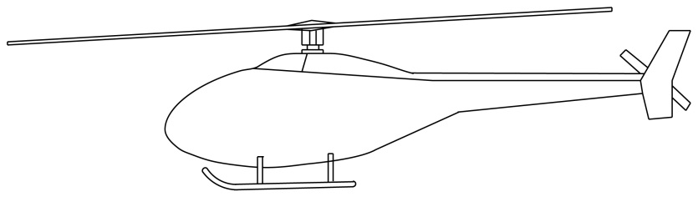

Lift

Drag

Thrust

Weight

Figure 8. Forces acting on a helicopter in flight

## 3.2 Wind

Of all the nonlinear dynamic forces affecting a helicopter in flight wind is the force that needs the most consideration; weight is probably the largest force but is relatively constant. The flight path of the helicopter or UAV relative to the climatic winds can have a bearing on the performance of the vehicle in question. As (Biven & Guercio, 1987, p. 8) explains a helicopter has a tendency to align itself with the direction of the relative wind, this needs to be counteracted with the tail rotor and is referred to as “Yaw Weathercock Stability”. Also the wind turbulence generated by the ships airwake, as the aircraft approaches the ship can have an adverse effect on the air vortices the rotors rely on for stable flight.

These winds can have a greater effect on smaller UAVs. Referencing Newton’s Second Law of Motion, F = ma, the force of the wind relative to the UAV’s mass and acceleration is greater than that acting on a manned helicopter.

## 3.3 Performance

There are a wide variety of VTOL UAVs in civilian and military use around the world each with its own unique characteristics. Vehicle size, shape, payload, engine power, fuel consumption and design all play their part in determining the performance of the helicopter. Coupled with this is the unique environment the aircraft is deployed in each time it carries out an operation. Rotomotion’s SR200 Helicopter UAV is a mid-range UAV achieving up to 5 hours of flight and with a maximum payload of almost 23kgs, details listed below. This UAV would meet a lot of the needs for a maritime surveillance operation.

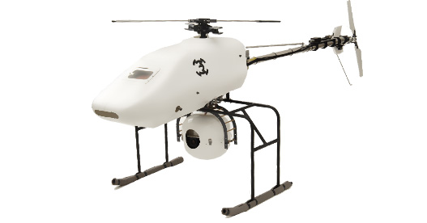

Figure 9. Rotomotion VTOL UAV

(Rotomotion, 2011)

|  |  |
| --- | --- |
| **UAV Specification Item** | **Specification** |
| Length | 2790 mm |
| Width | 760 mm |
| Height | 860 mm |
| Main Rotor (M/R) Diameter | 3000 mm |
| Tail Rotor (M/R) Diameter | 700 mm |
| Dry Weight | 25 kg |
| Fuel Capacity | 2 litres (18 litres available) |
| Engine | 150cc, 2-stroke engine |
| Generator | 800 W, 24 V alternator |
| Climb Rate | 2 ms-1 |
| Maximum Speed | Up to 60 km/h |
| Endurance | Up to 5 hours |
| Maximum Payload | 22.7 kg |
| Operating Ceiling | 1,500 m |

Figure 10. Rotomotion’s SR200 Helicopter specification

(Rotomotion, 2009)

A larger UAV, predominantly in military use, is the Schiebel Camcopter S-100. This UAV has been deployed by the French, Italian, Russian, and United Arab Emirate militaries. A partnership deal between Schiebel and Boeing helped expose the S-100 to the American market, where it was also presented to “U.S. Army Special Operations Command (USASOC) at Ft. Bragg” (Schiebel, 2009)

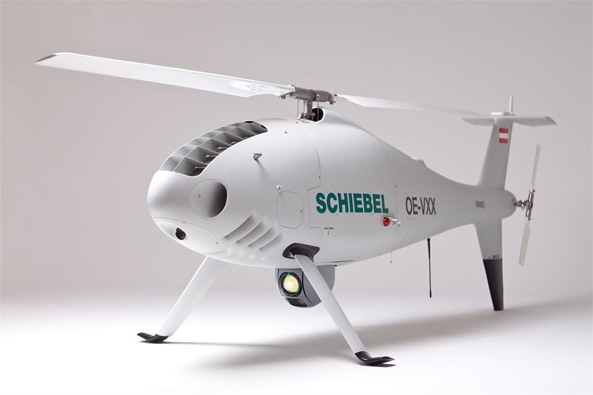

Figure 11. Schiebel Camcopter S-100 VTOL UAV

(Schiebel, 2013)

|  |  |
| --- | --- |
| **UAV Specification Item** | **Specification** |
| Length | 3110 mm |
| Height | 1120 mm |
| Main Rotor (M/R) Diameter | 3400 mm |
| Dry Weight | 110 kg |
| Maximum Payload | 50 kg |
| Fuel Capacity | 57 litres |
| Engine | 41 kW (55 HP) rotary engine |
| Maximum Speed | Up to 240 km/h |
| Endurance | Up to 6 hours |
| Operating Ceiling | 5400 m |
| Wind (takeoff and landing) | Up to 46 km/h |
| Data Link Range | Up to 180km |

Figure 12. Schiebel Camcopter S-100 specification

(Schiebel, 2013)

## 3.4 Navigation

All aircraft have an Inertial Navigation Systems (INS) and VTOL UAVs are no different. The digression though may be in the destination of that information. If the UAV is fully autonomous then the information is sent to the UAVs flight control system where the system determines the next control response to be undertaken. However if the UAV is under the control of a pilot then the INS information will be displayed on the pilots interface, which may be many kilometres away, for example Schiebel’s Camcopter S-100 can communicate with its pilot up to 180 km away.

The information processed by an aircraft’s INS can include; altitude, heading, pitch, roll, velocity and GPS. These values in conjunction with the mission objectives will determine the UAVs next course of action. Some INSs also employ secondary or redundant systems as fail safes. For example the KN-4072A unit, available from Kearfoot, also records barometric altitude which can be included in the “vertical loop in the absence of valid GPS data” (Kearfoot, 2011), which could be extremely important if a hostile force is interfering with a GPS signal.

Other navigational tools that are deployed on some UAVs include; radar, way points (the systems generate their own longitudinal/latitudinal points for the return leg of the operation) Ethernet, cameras, and high altitude imagery.

Combined, this array of sensors, receivers and equipment is known as the sensory bank and is often fitted under the aircraft away from the engine and rotors, reducing vibration as much as possible.

## 3.5 Response Times

The response time of helicopters and UAVs to flight control changes is difficult to provide. There are a number of factors that will affect the performance characteristics of the aircraft. These include; mass and payload, CoG and its location, wind and its direction, thrust at the time of control change and momentum relative to the desired control change. For example the helicopter or UAV may respond almost instantaneously, if the desired control change corresponds to the relative wind direction, however the same control applied in the opposite direction may have little or no impact if the force applied is not substantial enough to overcome the force of the relative wind

In his doctoral thesis on flight control for VTOL UAVs Yuan observed the dynamics of u, v and w the longitudinal, lateral and vertical velocities. When a closed-loop controller was implemented the expected change rates for u, v and w were recorded. These are shown below.

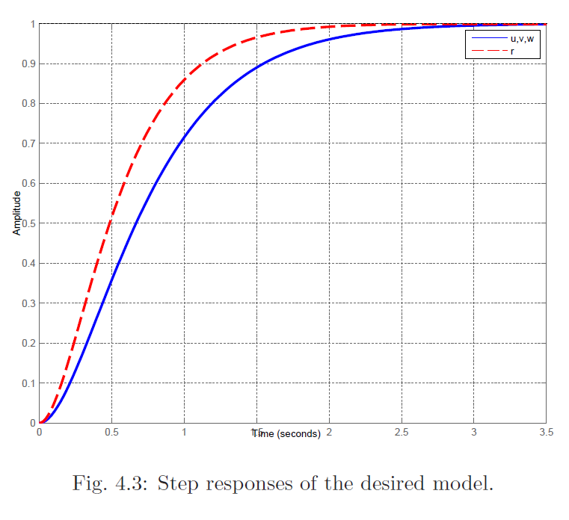

Figure 13. Yuan's finding for response times versus changes in vector u,v and w

(Yuan, 2013, p. 50)

As can be seen from the plot the rate of changes for the vector forces u, v and w are nonlinear. This is expected as the internal and external forces that affect these rates of change are also nonlinear e.g. acceleration, momentum, climatic and turbulence induced winds etc.

As the aircraft approaches the point at which a required alteration is nearing completion it is common for a flight controller to apply a dampening effect to the flight controls. In Yuan’s implementation he also investigates the need to “increase the damping ratio of the closed-loop system as the system output approaches the target reference to reduce the overshoot” (Yuan, 2013, p. 15)

Another factor in the control of UAVs (piloted) is the human response times which (Biven & Guercio, 1987, p. 45) states is “0.3 sec, which is representative of the human neuromuscular time delay”. This delay could be further extended if the pilot is under pressure to perform multiple tasks at once which is normally the case when operating the controls of a helicopter UAV.

## 3.6 Camera

Like the sensory array available to the UAV there is also a wide variety of cameras that are available to the aircraft. One of the only disqualifying factors would be the net mass of the camera and the UAVs payload capabilities. A high end camera system is supplied by Hood Tech Vision. The 11EOIR1 is a “mid-wave infrared and electro-optical imaging system … designed for small unmanned aerial vehicles” (Hood Tech Vision, 2013) selected details are below.

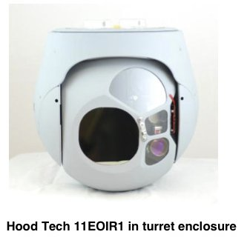

Figure 14. Hood Tech Vision - 11EOIR1

(Hood Tech Vision, 2013)

|  |  |
| --- | --- |
| **Specification Item** | **Specification** |
| Field of View | MWIR: 2°-25° EO: 1.7°-57° |
| Pixels | MWIR: 640 x 480 EO: 720 x 480 |
| Wavelength | MWIR: 3-5 µm EO: 400-900 nm |
| Zoom (optical) | MWIR: 12.5X EO: 36X |
| Communications | Nominal: Serial communication, 57,600 bps |
| Video | Composite NTSC |
| Weight | 5,700 g with enclosure |

Figure 15. Hood Tech Vision - 11EOIR1 specifications

(Hood Tech Vision, 2013)

## 3.7 Summary

Helicopters and VTOL UAVs are naturally unstable aircraft. Their operation is affected by a list of nonlinear variables as they operate in six degrees of freedom. That been said they are ideally suited for certain operations that cannot be performed by winged aircraft. One of these is landing in a confined area. This project proposes to examine the interaction between some of these nonlinear variables and the projected movements of a UAV in 3D space as it approaches touchdown on the deck of a ship. Although the movement and responses of the aircraft are hard to establish definitively, an operational response envelope of 0.5ms-1 in all 3 axis of 3 dimensional space is expected. This expectation is a minimum would be relative to any acceleration or momentum already acting on the aircraft.

# 4 Final Approach

## 4.1 The Four Phases

As discussed by (Shin, You, & Shim, 2013) and (Fang, et al., 2003) the landing of a helicopter on the deck of a ship can be described in four distinct phases. The helicopter is in “Tail-Chasing Mode” when there is greater than 350m between the helicopter and the ship. When the helicopter enters the range between 350m and 50m, the aircraft is in the “Approach Mode”, at this stage it is also recommended to lower altitude to 30m. To proceed, the helicopter then enters the “Descending Mode” reducing altitude, matching velocity with the ship and finally touching down in the “Landing Mode”.

## 4.2 Landing Approaches

With reference to the landing of a helicopter, Fang, et al. also goes on to explain from page 1-18 that to their “knowledge there are six different procedures which are being applied worldwide”. Three of the main procedures are described as;

“Fore/aft or forward facing procedure”

“Relative-wind or into wind procedure”

“Cross-deck procedure”.

When deciding on a desired and/or required landing approach the polit of a helicopter must consider many factors, one of the main considerations when evaluating a flight path is the crosswind and the direction of the crosswind relative to the ship (Shin, You, & Shim, 2013, p. 771).

## 4.3 Touchdown

When the UAV approches touchdown it can be in a percarious state. The aircraft can be prone to slip and rotational momentium as the movements of the ship are now imposed on the aircraft. If a helicopter in the process of landing, touches down on one side while still amost airbourne it is possible the aircraft may ‘slip’ laterally. This issue could then be compounded if the landing gear strikes an obstacle, adding momentum about the landing gear pivot point.

“When the helicopter comes in contact with the ground and a new pivot point is established the moment of inertia about the roll axis increases nearly five-fold due to this displaced pivot point” (Lobik, 2003). The rotational momentum of the ship can compound this issue, but it can also have adverse affects on the aircraft alone. If the centre of gravity and the tipping point of the aircraft approach each other as the ship rolls the aircraft will be prone to dynamic rollover. Any state of instability will continue until the aircraft has lost suffient lift to insure gravity will hold it in place on the deck of the shipor the aircraft mechanically secured or stowed away.

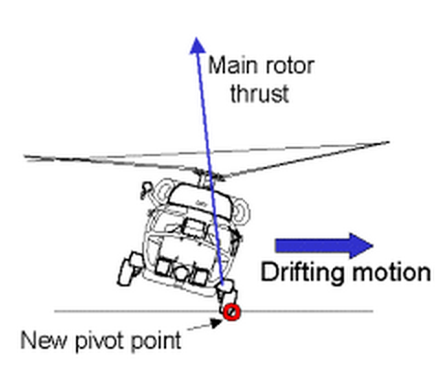

Figure 16. Lobik's diagram showing lateral ‘slip’ as a helicopter is landing or taking off

(Lobik, 2003)

## 4.4 Summary

The final stages of a helicopter or UAV flight, as it attempts to touch down on the deck of a ship involve complex operations. The skill and coordination of the pilot or UAV operator must be up to the task at hand. The proposed system will focus on this stage of VTOL aircraft flight, and in particular UAV landings.

# 5. Commercial and Academic Landing Assist Systems

There are a number of commercial systems on the market that offer similar functionality as that proposed for this project. There are also many academic papers that have investigated the issues discussed here. The commercial products discussed below use positioning systems either local or global. The academic papers outlined in section 5.2 employ various methods to aid in the landing.

## 5.1 Commercial Systems

Astrium’s ‘DeckFinder’ system uses deck mounted “Pseudo-Satellites” to provide a local positioning system which operates without the need for Global Positioning Systems. The system delivers positional accuracy of 20cm at a rate of up to 15Hz to a range of up to 1.1km (Astrium, 2013).

NovAtel have developed an “Automated Flight Control System” which uses their navigational systems to autonomously land a drone helicopter. These navigational systems use GPS and INS data from the ship and the UAV. This system was tested successfully in conjunction with Boeing’s H-6U VTOL UAV on 4th July 2012 when the UAV was autonomously landed on the deck of a moving ship (NovAtel, 2012).

## 5.2 Academic Systems

At the 2013 International Conference on Unmanned Aircraft Systems, (Shin, You, & Shim, 2013) presented a paper which evaluated an algorithm for the landing of a UAV autonomously. The paper investigates the use of a Time-Delay Control and a MatLab simulation to validate the results. The algorithm makes allowances for crosswind, and the different landing phases a VTOL UAV must negotiate to touch down successfully. The performance of the time delay controller, which is modelled on a model reference adaptive controller, is compare to the results from a conventional proportional derivative controller. Shin’s finding showed that “the landing system generated optimal landing procedures based on the Navy procedures”.

Another paper presented at the Unmanned Aircraft Systems conference by (Sanchez-Lopez, Saripalli, Campoy, Pestana, & Fu, 2013) discusses the use of a colour camera fixed to a UAV to aid in the its landing on the deck of a ship. The UAV in this case also uses sonar to determine the difference in altitude between the ship and the aircraft. Their simulation for the ship was based on an Oliver Hazard Perry Class FFG Frigate operating in sea state six. The system uses image recognition and extraction to acquire the optimal landing coordinates and the model’s performance was satisfactory in “the first steps required to achieve a solution to the challenge of autonomously landing on a ship”.

In the IEEE journal, Transactions on Robotics (Herissé, Hamel, Mahony, & Russotto, 2012) reported on the findings of their paper on VTOL UVA landings on a moving target using optical flow. Their control algorithms used the optical flow measurements obtained from a camera fixed to the centre of mass of the UAV. They explained that the results “show that the proposed scheme is effective” although it was observed that improvements in the response times for the camera would help improve the effectiveness of the closed loop controller.

In their paper Esmailifar and Saghafi propose a UAV landing system which employs a multilevel controller to track the target and land on a platform which moves with six DoF. This is achieved in two distinct phases, the “Supervisor level” which deals with intercepting the ship and the “Tracking level” which tracks the attitude differences between the aircraft and the ship. In evaluating the landing system’s performance the motion of the ship is modelled on a sinusoidal wave. They concluded that the performance of the simulation was satisfactory as “the helicopter is able to track the ship states in both landing phases” (Esmailifar & Saghafi, 2009).

## 5.3 Summary

There have been many academic papers on proposed landing systems for helicopters and VTOL UAVs but the same does not seem to be the case for their commercial equivalents. On 4th July 2012 NovAtel and Boeing claimed to have been the first to successfully land a UAV on the deck of a moving ship (NovAtel, 2012). This is surprising considering the level of research into this sector of aerial systems, and could indicate the complexity involved in implementing the research models in real life applications.

# 6. System Overview and Prototype

## 6.1 Use Case Diagram



## 6.2 High Level State Diagram



## 6.3 System Architecture

It is proposed to use a three tier architectural design, consisting of a GUI presentation layer, a control layer and two business layers. The implementation of two business layers will provide a layer of separation between the business logic for the two models.

It is proposed to build the presentation layer as a collection of Unity (Unity, 2013) ‘scripts’. These C Sharp classes will be developed in the Visual Studio editor which is available direct from Unity. In order to harness the functionality of the Unity game engine, the presentation layer classes need to implement the Unity interface ‘MonoDevelop’. The implication of using Unity with this configuration is the difficulty testing this element of the project. The testing of ‘gameObjects’ and their relative motion in a virtual 3D space would involve substantial effort. As an alternative it is proposed to remove any business logic from presentation layer and implement it in the lower layer of the architecture. The lower levels of the architecture will not implement MonoDevelop and so NUnit (NUnit, 2013) or a similar testing framework will be available to the system.

## 

## 6.4 Component Diagram

## 

## 6.5 Prototype

To develop a prototype a number of different platforms were investigated. First the MatLab IDE (MathWorks, 2013) was evaluated and although the platform is suitable to perform the task in hand it is not available as an open source application and only offers a 30 free trial. Following on from the evaluation of MatLab, iPython (IPython, 2013) and Pythonxy (pythonxy, 2013) were investigated but the initial results proved disappointing. It was an aspiration to provide a 3D plot from two live streams but it was felt that the visual results may not demonstrate the interaction between the UAV and the ship to an acceptable level of detail.

Finally Unity was evaluated. This game engine is open source and proved to have an acceptable level of processing power, visual display elements and coupled with the option of using Visual Studio and the main script editor it was felt that this configuration offered advantages over the other platforms.

Another application, Blender (Blender, 2013) was used to create a basic model of a ship. This scale model approximates the size of DDG 51 Arleigh Burke destroyer and was then imported into Unity as a program asset.

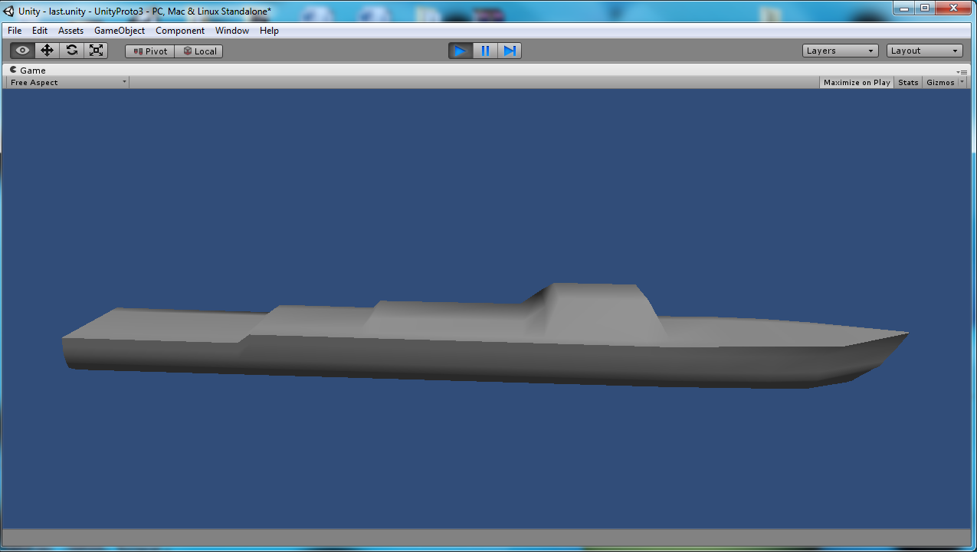

When the model is ‘playing’ the application can produce coordinates for points on model as it virtualises movement in 3D space. It is proposed to harness these coordinates to provide a dataset for the movement of the landing pad relative to the ships poise.

Vector3 point = gameObject.transform.position;

print(point.x + ", " + point.y + ", " + point.z);

A sample of the data recorded for the motion of the model is shown below. This particular dataset only applies to the centre point of the model and so does not show responses to rotation, as the model rotates around it centre point. It is proposed to add a number of reference points to the model that can then be tracked.

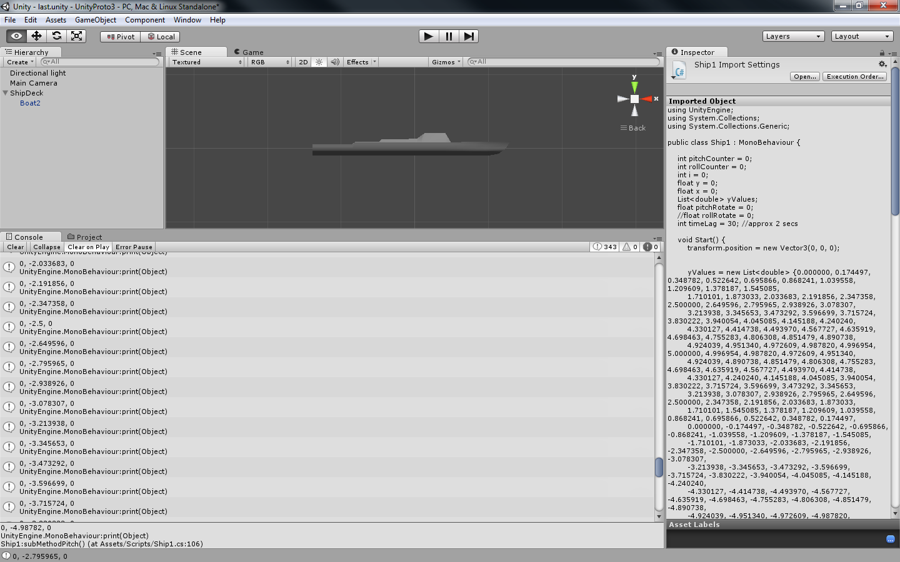

# 7. Equations of Motion

## Degrees of Freedom

## Eularian Angles

## The 2D Plane

# 8. Influencing Factors

## Time Delay Factors

# 9. The UAV Model

# 10. The Ship Model

# 11. From Target Acquisition to Touchdown

# 12. Results

# Appendix

## Appendix 1 Douglas Sea Scale

Douglas Sea Scale (Met Office, 2010)

|  |  |  |  |
| --- | --- | --- | --- |
| Code | Height (m) | Sea State | Swell Description |
| 0 | 0 | Calm (glassy) | No Swell |
| 1 | 0 - 0.1 | Calm (rippled) | Very low (short and low wave) |
| 2 | 0.1 - 0.5 | Smooth (wavelets) | Low (long and low wave) |
| 3 | 0.5 - 1.25 | Slight | Light (short and moderate wave) |
| 4 | 1.25 - 2.5 | Moderate | Moderate (average and moderate wave) |
| 5 | 2.5 - 4.0 | Rough | Moderate rough (long and moderate wave) |
| 6 | 4.0 - 6.0 | Very rough | Rough (short and heavy wave) |
| 7 | 6.0 - 9.0 | High | High (average and heavy wave) |
| 8 | 9.0 - 14.0 | Very high | Very high (long and heavy wave) |
| 9 | Over 14.0 | Phenomenal | Confused (wave length and height indefinable) |

Fig#####

# Works Cited

Astrium. (2013, July 10). *Key Features*. Retrieved November 28, 2013, from DeckFinder: http://deckfinder.net/key-features/

Biven, C. C., & Guercio, J. G. (1987). *A Simulation Investigation of Scout/Attack Helicopter Directional Control Requirements for Hover and Low-Speed Tasks.* California: National Aeronautics and Space Administration. Retrieved November 4, 2013, from https://www.google.ie/url?sa=t&rct=j&q=&esrc=s&source=web&cd=10&cad=rja&sqi=2&ved=0CGUQFjAJ&url=http%3A%2F%2Fwww.dtic.mil%2Fcgi-bin%2FGetTRDoc%3FAD%3DADA185874&ei=Mw59UuHCIIqV7Qa5s4DAAg&usg=AFQjCNHJ8Z4-ncgeOfiU-7ki8WCqHVN4Iw&bvm=bv.56146854,d.ZGU

Blender. (2013, October 31). *Blender 2.69*. Retrieved November 24, 2013, from Blender: http://www.blender.org/download/

Din, A., Bona, B., Morrissette, J., Hussain, M., Violante, M., & Naseem, F. (2012). Embedded Low Power Controller for Autonomous Landing of Small UAVs using Neural Networks. *10th International Conference on Frontiers of Information Technology* (pp. 196-203). Islamabad: Conference Publishing Services & IEEE Computer Society. Retrieved October 6, 2013, from http://0-ieeexplore.ieee.org.acpmil13web.ancheim.ie/stamp/stamp.jsp?tp=&arnumber=6424321

Esmailifar, S. M., & Saghafi, F. (2009). Autonomous Unmanned Helicopter Landing System Design for Safe Touchdown on 6DOF Moving Platform. *Fifth International Conference on Autonomic and Autonomus Systems* (pp. 245-250). Valencia: IEEE. Retrieved October 26, 2013, from http://0-ieeexplore.ieee.org.acpmil13web.ancheim.ie/stamp/stamp.jsp?tp=&arnumber=4976611

Fang, R., Krijns, W., Finch, R. S., Geyer, W. P., Long, K., & Carico, D. (2003). *Helicopter/Ship Qualification Testing.* North Atlantic Treaty Organisation/Research and Technology Organisation, The Research and Technology Organisation (RTO) of NATO. Ottawa: St. Joseph Print Group Inc. Retrieved October 19, 2013, from https://www.google.ie/url?sa=t&rct=j&q=&esrc=s&source=web&cd=1&cad=rja&ved=0CCwQFjAA&url=http%3A%2F%2Fwww.dtic.mil%2Fcgi-bin%2FGetTRDoc%3FAD%3DADA411975&ei=W6hiUoalA8eshQe1yICYCw&usg=AFQjCNH8bYfwU1lJw8j0ueLwmMsj89JhLQ&bvm=bv.54934254,d.ZG4

Federal Aviation Administration. (2012). *Helicopter Flying Handbook.* Oklahoma City: United States Department of Transportation. Retrieved November 4, 2013, from http://www.faa.gov/regulations_policies/handbooks_manuals/aviation/helicopter_flying_handbook/media/helicopter_flying_handbook.pdf

Florida Centre for Instructional Technology. (2005). *Waves in the Ocean.* Retrieved November 15, 2013, from fcit.usf.edu: http://fcit.usf.edu/florida/teacher/science/mod2/resources/waves.pdf

Herissé, B., Hamel, T., Mahony, R., & Russotto, F.-X. (2012). Landing a VTOL Unmanned Aerial Vehicle on a Moving Platform Using Optical Flow. *Robotics, IEEE Transactions on (Volume:28 , Issue: 1 ), 28*(1), 77-89. doi:10.1109/TRO.2011.2163435

Hood Tech Vision. (2013). *Hood Tech Vision Product Summary Table.* Retrieved November 9, 2013, from www.hoodtechvision.com: http://www.hoodtechvision.com/products.html

IPython. (2013, September). *IPython Interactive Computing*. Retrieved November 24, 2013, from ipython.org: http://ipython.org/

Kamalasadan, S., & Ghandakly, A. A. (2011). A Neural Network Parallel Adaptive Controller for Fighter Aircraft Pitch-Rate Tracking. *Instrumentation and Measurement, IEEE Transactions on* , 258-267. doi:10.1109/TIM.2010.2047310

Kearfoot. (2011, August). *KN-4072A Airborne INS/GPS*. Retrieved November 9, 2013, from www.kearfott.com: http://www.kearfott.com/images/stories/pdf/DATASHEETS_KGN_NJ/AIR/kn-4072a_avionics_ins-gps.pdf

Lobik, M. D. (2003, March 14). *Helicopter Dynamic Rollover.* Retrieved November 20, 2013, from Nav Air: http://www.navair.navy.mil/safety/toolkit.cfm

MathWorks. (2013). *MatLab 30-Day Free Trial*. Retrieved November 24, 2013, from MathWorks: http://www.mathworks.co.uk/programs/nrd/matlab-trial-request.html?ref=ggl&s_eid=ppc_6060

McDonald, M. (1993). *SHF SATCOM Terminal Ship-Motion Study.* Technical Report, United States Navy, Naval Command, Control and Ocean Surveillance Centre, San Diego. Retrieved September 27, 2013, from http://www.spawar.navy.mil/sti/publications/pubs/tr/1578/tr1578.pdf

Met Office. (2010). *The Beaufort Scale.* Retrieved October 10, 2013, from www.metoffice.gov.uk: http://www.metoffice.gov.uk/media/pdf/b/7/Fact_sheet_No._6.pdf

NovAtel. (2012). *Automated Flight Control System*. Retrieved November 28, 2013, from www.novatel.com: http://www.novatel.com/technology-in-action/automated-flight-control/

NUnit. (2013, October 10). *NUnit - Home*. Retrieved from www.nunit.org: http://nunit.org/index.php?p=home

Padfield, G. D. (2007). *Helicopter Flight Dynamics* (2nd ed.). Oxford: Blackwell Publishing. Retrieved October 12, 2013, from http://www.foinikas.org/ftp/public/DCS%20Blackshark/HELICOPTER%20FLIGHT%20DYNAMICS.pdf

Prism Defence. (2010). *Prism Defence*. Retrieved November 20, 2013, from www.prismdefence.com: http://www.prismdefence.com/index.html

pythonxy. (2013, November 21). *Downloads*. Retrieved November 24, 2013, from pythonxy Scientific-oriented Python Distribution based on Qt and Spyder: https://code.google.com/p/pythonxy/wiki/Downloads?tm=2

Rotomotion. (2009, November). *SR200 Helicopter UAV Specifications.* Retrieved from www.rotomotion.com: http://www.rotomotion.com/datasheets/sr200_uav_sheet.pdf

Rotomotion. (2011, Feburary 14). *SR 200*. Retrieved from www.Rotomotion.com: http://www.rotomotion.com/r_product_5_sr200.html

Sanchez-Lopez, J. L., Saripalli, S., Campoy, P., Pestana, J., & Fu, C. (2013). Toward visual autonomous ship board landing of a VTOL UAV. *Unmanned Aircraft Systems (ICUAS), 2013 International Conference on* (pp. 779-788). Atlanta: IEEE. doi:10.1109/ICUAS.2013.6564760

Sandino, L. A., Bejar, M., & Ollero, A. (2011). On the applicability of linear control techniques for autonomous landing of helicopters on the deck of a ship. *Mechatronics (ICM), 2011 IEEE International Conference on*, 363-368. doi:10.1109/ICMECH.2011.5971312

Schiebel. (2009, December 16). *Schiebel Press*. Retrieved November 9, 2013, from www.schiebel.net: http://www.schiebel.net/AcmsFile/1311/0/550/2009-12-16_Schiebel_demonstrates_CAMCOPTER_S-100_t.pdf

Schiebel. (2013). *CAMCOPTER-S-100*. Retrieved November 8, 2013, from www.schiebel.net: http://www.schiebel.net/Products/Unmanned-Air-Systems/CAMCOPTER-S-100/System.aspx

Schiebel. (2013). *Image-Gallery*. Retrieved from www.schiebel.net: http://www.schiebel.net/AcmsFile/1782/0/550/CAMCOPTER_S-100_084.jpg

Shin, H., You, D., & Shim, D. H. (2013). An autonomous shipboard landing algorithm for unmanned helicopters. *Unmanned Aircraft Systems (ICUAS), 2013 International Conference on* (pp. 769-778). Atlanta: IEEE. doi:10.1109/ICUAS.2013.6564759

Snyder, C. M. (2012). Validation of Ship Air Wake Simulations and Investigation of Ship Air Wake Impact on Rotary Wing Aircraft. *Launch & Recovery.* Maryland: American Society Naval Engineers. Retrieved November 15, 2013, from http://www.cobaltcfd.com/pdfs/ASNE_2012_ship_airwake_snyder.pdf

Tang, Y.-R., & Li, Y. (2012). Design of an optimal flight control system with integral augmented compensator for a nonlinear UAV helicopter. *Intelligent Control and Automation (WCICA), 2012 10th World Congress on* (pp. 3927-3932). Beijing: IEEE Conference Publications. doi:10.1109/WCICA.2012.6359128

Techet, A. H. (2004, September 8). *Hydrodynamics for Ocean Engineers.* Retrieved November 20, 2013, from web.mit.edu: http://web.mit.edu/13.012/www/handouts/Reading3.pdf

Techet, A. H. (2005). *Ocean Waves.* Retrieved November 15, 2013, from web.mit.edu: http://web.mit.edu/13.42/www/handouts/wave_spectra_slides2.pdf

Unity. (2013). *What is Unity and what can I do with it?* Retrieved November 24, 2013, from Unity: http://unity3d.com/pages/create-games?gclid=CMbP-6Pi_roCFWd72wodkgkAgA

Yu, Z., Nonami, K., Shin, J., & Celestino, D. (2007). 3d vision based landing control of a small scale autonomous helicopter. *International Journal of Advanced Robotic Systems, 4*(1), 51-56. Retrieved October 12, 2013, from http://cdn.intechopen.com/pdfs/4211/InTech-3d_vision_based_landing_control_of_a_small_scale_autonomous_helicopter.pdf

Yuan, W. (2013, August 5). Dynamic Modelling and Flight Control Methodologies for Vertical Take-Off and Landing Unmanned Aerial Vehicles. Sydney, New South Wales, Australia. Retrieved November 9, 2013, from https://www.google.com/url?sa=t&rct=j&q=&esrc=s&source=web&cd=23&cad=rja&ved=0CDIQFjACOBQ&url=http%3A%2F%2Funsworks.unsw.edu.au%2Ffapi%2Fdatastream%2Funsworks%3A11442%2FSOURCE01&ei=i9Z_Up21JceQhQfsp4DgCg&usg=AFQjCNEB8SQgD8Xr4TLfM9_YGd-WK4ipYw&bvm=bv.56146